

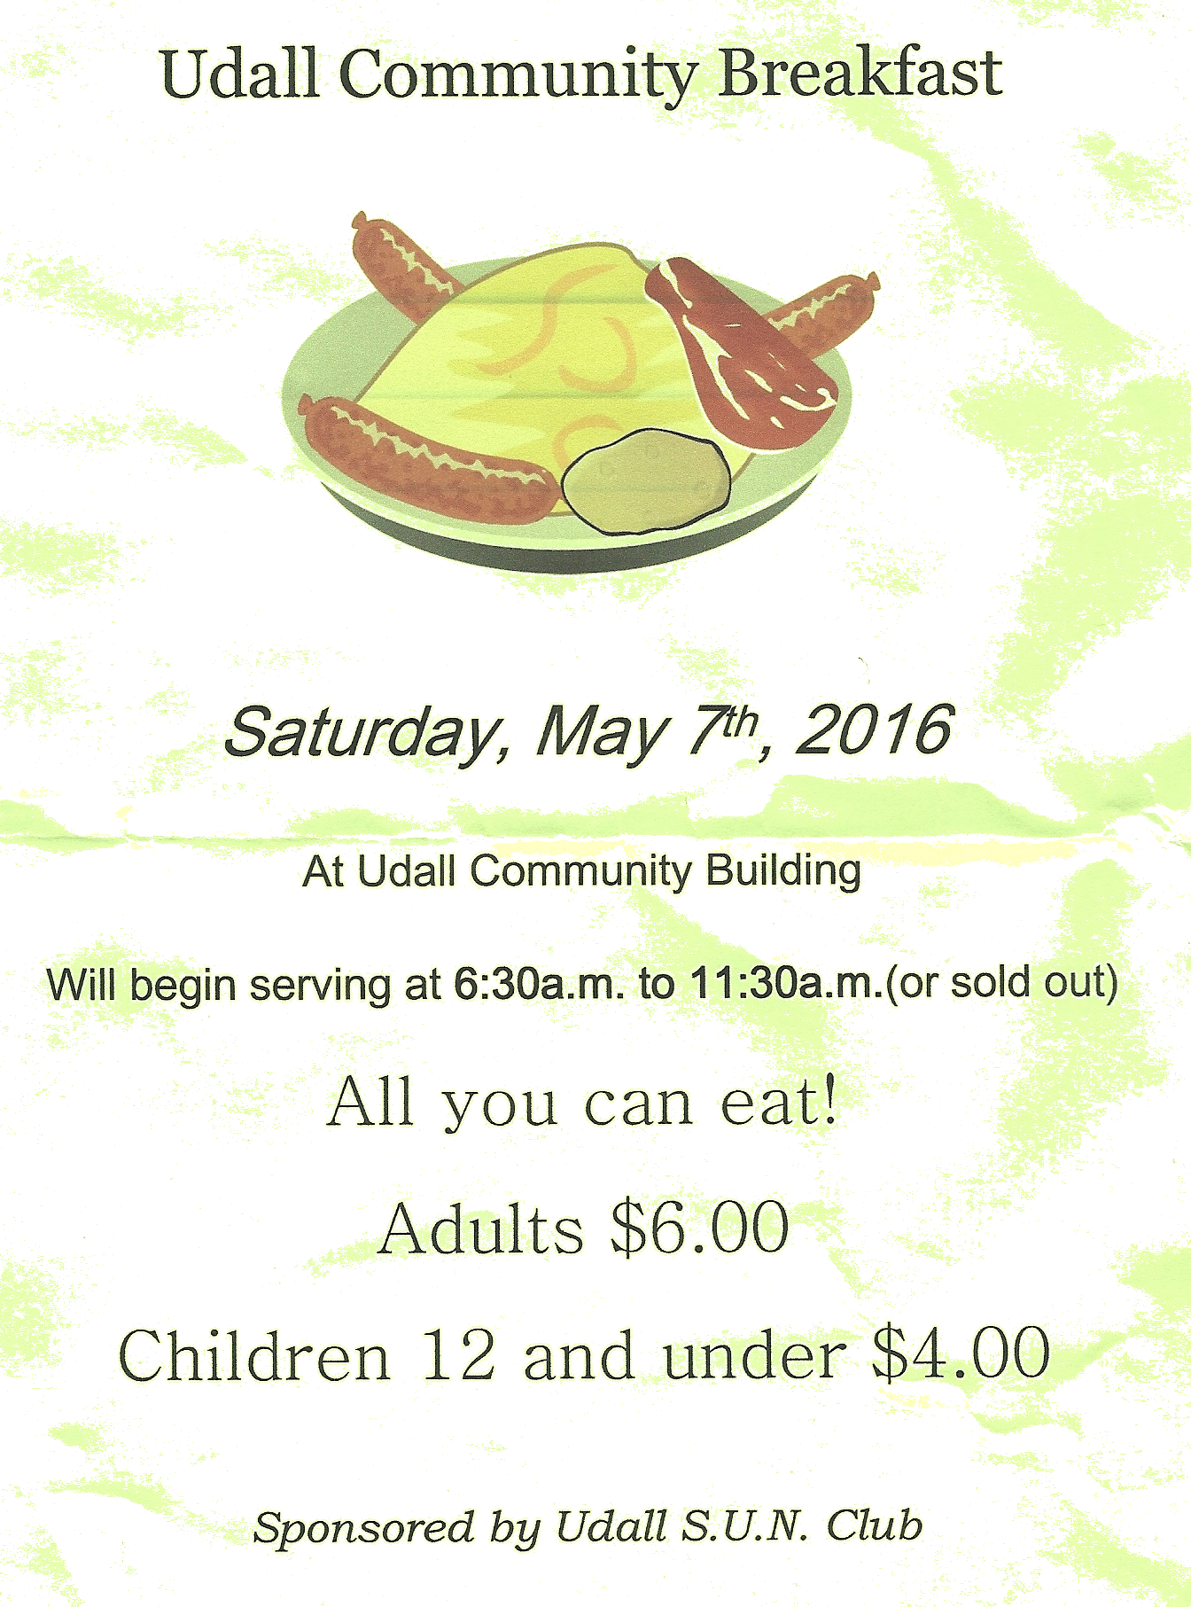
From Mayor Steve Brown,
Hello everyone, I know there has been discussion in the community about the building project that the city is currently proposing to build. With that, I would like to offer some facts and also offer reasons why I feel it is important to proceed with this project.
First, no new taxes will be levied for this building. Nor will there be any rate increase in city services, such as electricity, for the funding of this project. Currently the city has an annual payment of $43,530.00 for our street sweeper, our last payment will be May of 2021. This $43,530.00 will go back to the general fund, and then be used for our loan payments to USDA, that we will apply for, for the construction of this building. The city will also apply for a Community Development Block Grant, which will pay for the other half of this project. Our city is doing very well financially, while all the while we have been experiencing a downward trend in taxes, as can be seen by the graph on the next page. So I repeat, there will be no tax increase or utilities increase to fund this building.
Lou Hopkins and I will meet with William Newton Memorial Hospital on August 28th to discuss their involvement in this project. Information from this meeting will be distributed to the community as soon as possible. There is some concern among the community that libraries are of no value to cities any longer. I find that to be a disturbing revelation. I know this is not true, the success of Mulvane’s new library speaks to that concept as being uninformed. The City of Mulvane has around seven thousand residents and their library has three thousand library cards on record. I stopped by to visit with the Mulvane staff and they report that they are busy from 3:00 pm until closing, every day. It was mentioned on social media that the Udall Library had 200 visitors last year. And this person wondered if that was enough to qualify for a new facility. I say yes it does, we have a population of 750, 200 is more than a quarter of our population currently using the library. To date our usage for 2018 is 44 adults and 65 children. With an updated and larger facility, the library will be able to offer more services and programs. We can expand operational hours to 39 hours and still not increase taxes or utilities.

Udall Community Building
Saturday, September 1, 2018
7:00 am – 10:00 am
Pancakes, Biscuits & Gravy,
Sausage, Bacon, Fried Potatoes,
Scrambled Eggs & Fruit
Along with the library the Wellness Center will provide a clinic and a fitness area, for the health and well-being of our citizens. Why travel to another town when we can have all of these services here? And lastly we come to a reason that is as equally important as the services this project will create. That reason is simply to start Udall on a path of rebuilding our downtown area. With one new building will come another, but only if we as a community commit to making Udall a vibrant and relevant city.
I will end with the words of councilperson Lila Aimes, “We need to start somewhere. And this is where we start”.

Stephen R. Brown
Mayor, City of Udall

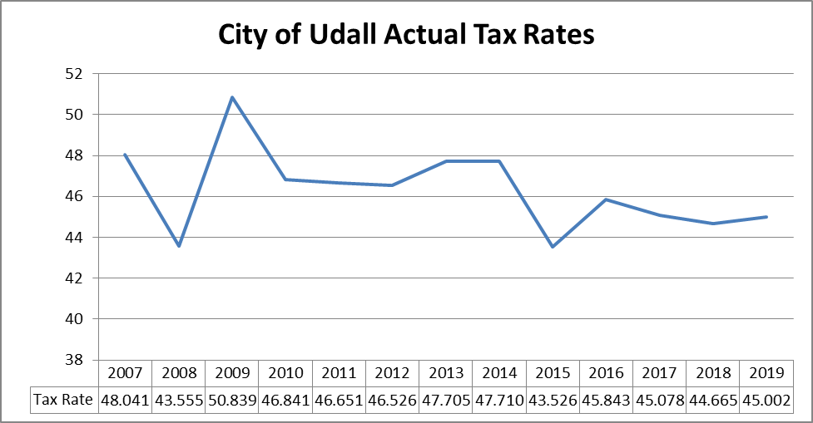
Proposed rate for
For those concerned with rumors that our tax rate will be increased for the Library/Wellness Center –
- The above graph represents the ACTUAL tax rates for the City of Udall for the past 11 years and the proposed rate for 2019. This indicates a downward trend being a full 3 pts less than 12 years ago.
- During that time the City of Udall has completed numerous projects that have been funded with the approval of the State and Federal officials including
  - Phase I Water Project replacing water tower and main water lines
  - KAN-STEP project renovating the Udall Community Building
  - Kansas Housing Resources Corporation HOME grant(s) assisting qualified individuals and their residences in home owner rehabilitation
  - Dept of Commerce Small Communities Improvements Program – upgrades to City park including Amphitheater and surfaced playground area
  - Phase II Water Project replacing remaining main water lines
- Also during this timeframe, the Splashpad has been constructed in the City Park. This was funded through donations from local organizations and partially by the City of Udall. This one project has been very beneficial to the City as we are continually visited by surrounding community members who enjoy this summer attraction. During the summer months, the city office is contacted several times a week asking about the Splashpad, when it is open, do they need to reserve a picnic pavilion – always complimenting the city on this activity where they can bring their children. Several communities have come here, or called, requesting information on the project and how it was funded so they can possibly do the same in their town.


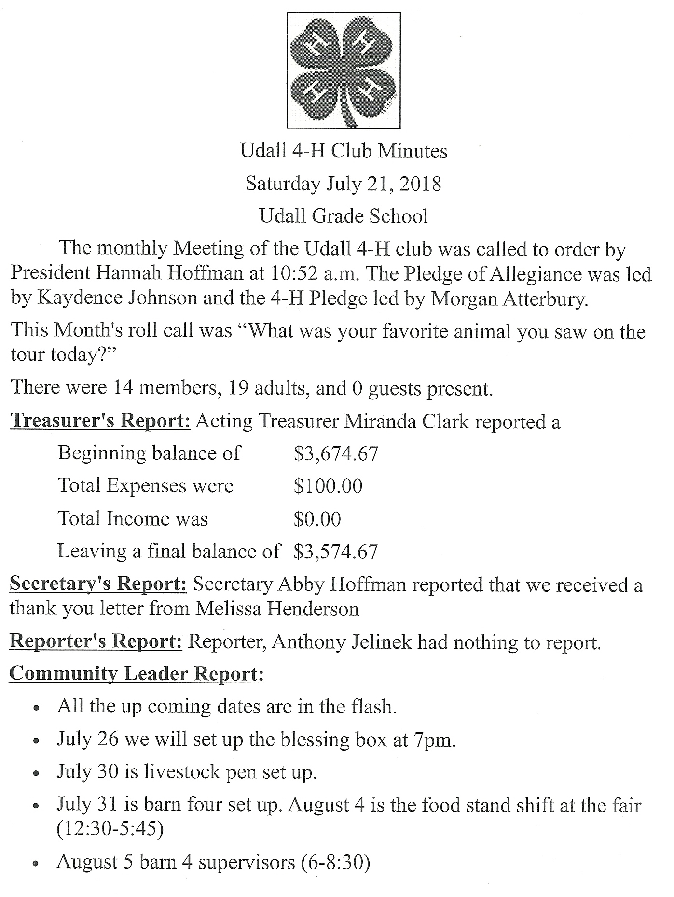
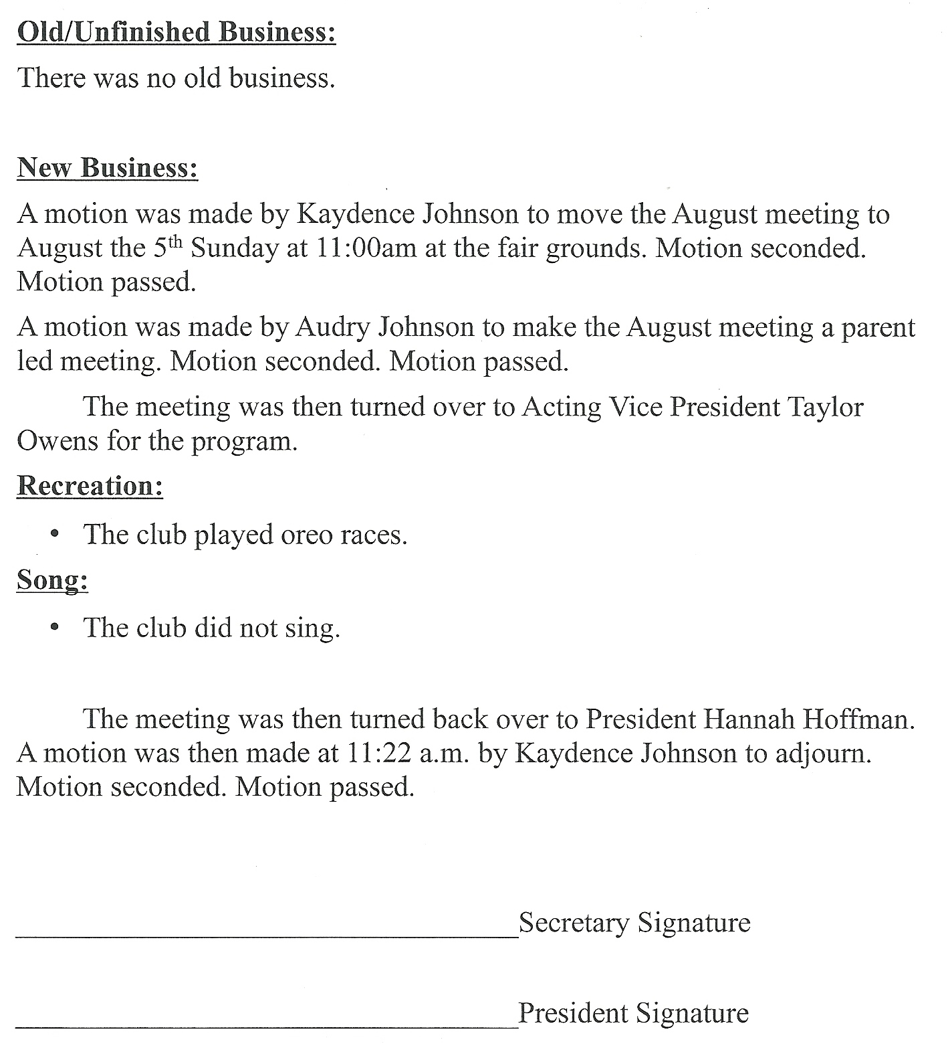
REGULAR COUNCIL MEETING CITY OF UDALL Monday, July 9, 2018
The Udall City Council met for the regular meeting on Monday, July 9, 2018, at 6:30 p.m., at the city building. Stephen R. Brown, Mayor, called the meeting to order. Roll call was then taken with the following council members present: Michael Grahem, Randall Smith, Jason Tharp and Damon Wilson. Quorum established. Attending were Sarah Martin, Kristen McReynolds, William McReynolds, Beth Evans, Norma Ciskowski, Rose Mary Saunders, Lyle Pfannenstiel, Joe Clasen, Erik King, Eric Allen, and Lulita Hopkins. Also arriving later in the meeting were David Devore and council member Lila Aimes.
MODIFICATION OF AGENDA:
MOTION: by Smith, second by Wilson, to amend the agenda adding Item #4 to New Business; CMB application. All voted aye, motion carried.
BUSINESS FROM THE FLOOR: Sarah Martin addressed the council representing the NICE committee. They would like to explore the possibilities of a share over the area surrounding the Splash Pad. Derby’s new park has triangle shaped shades over portions of their playground area for those accompanying the children playing. She will research prices and availability and discuss with Eric Allen.
GENERAL DISCUSSION:
- Lyle Pfannenstiel – Mr. Pfannenstiel had presented a building permit for a privacy fence along the west side of his property and 16 ft east of the southwest corners. This was also presented and a variance to the Udall Planning Commission that responded with a denial of the variance due to not wanting to set a precedence for future variance requests and compromising both the city and the school’s access to utilities. The particulars of his request were discussed and UPC Chairperson Joe Clasen referred from the City’s zoning ordinances that double frontage is required on both front yards of an end or corner property.
Mr. Pfannenstiel exited the meeting.
- July 21 – Movie Night in the Park will present THE SANDLOT at 8:45 p.m
CONSENT AGENDA:
MOTION: by Smith, second by Aimes, to approve the consent agenda including the Clerks and Treasurer’s Reports for June 2018, the minutes of June 11 and June 18, Expenditure Report of $150,810.82 and Payroll Account Report Totals of $19,294.26. All voted aye, motion passed.
OLD BUSINESS:
- Review Changes to Udall Library/Wellness Center – David Devore presented the council members and others with revised floor plans and interior drawings of the project. These reflected changes requested at the latest planning session. Letters of support have been presented to the Udall City Council by both the Udall SUN Club and the Udall NICE Committee. In discussions with William Newton Memorial Hospital, they anticipate using the facility up to five days a week and the Derby Physical Therapy group indicated they would be using the wellness center possibly three days a week. Library board member Norma Ciskowski suggested the available personal computers for the public be reduced from six to four; as four would double the amount currently available for use by the public. The movable glass partition between the library area and the multi-purpose room was discussed. This will visually increase the size of the room and yet allow meetings to be held in a separate area. There was a consensus these plans would meet the needs of the majority with the addition of 250-350 ft area for children within the fitness center portion.
MOTION: by Aimes, second by Wilson, to approve the design with the addition of 250-350 foot area for children within the fitness center. Mayor Brown called for a vote by raising hands. Smith, Aimes and Wilson vote aye, Tharp and Grahem voted nay. Motion carried.
Rose Mary Saunders, of Ranson Financial, presented a proposed time table for the project. Some future items include the September 10th CDBG Public Hearing and application due date of November 1, 2018. The tentative award announcement will be in mid January 2019.
Also presented were examples of project costs and available for CDBG grant funds.
EXAMPLE PROJECT COST: $1,000,000 $900,000 $850,000
LESS CDBG Application Amount 600,000 600,000 600,000
Local Funding (USDA Loan) $400,000 $300,000 $250,000
- City Treasurer position – more application are anticipated to arrive this week. Treasurer selection will be tabled to the next meeting. However, there is a need to an additional signer on the checking account.
MOTION: by Wilson, second by Smith, to add Michael Grahem as an additional signer on the checking account temporarily until a City Treasurer is selected. All voted aye, motion carried.
MOTION: by Smith, second by Wilson, to table City Treasurer selection to the next meeting. All voted aye, motion carried.
- Bid for dance floor for city park – some of the bids received indicated they would not be completed until this fall.
MOTION: by Smith, second by Grahem, to table item until further estimates are received. All voted aye, motion carried.
NEW BUSINESS:
- John Beard – open position on Udall Planning Commission.
MOTION: by Wilson, second by Grahem, to approve appointment of John Beard to Udall Planning Commission. All voted aye, motion carried.
- First draft 2019 Budget – the budget was distributed to council members for their review. Budget requirements include publication of the proposed budget prior to the Budget Hearing scheduled for August 13. The council wished to review the proposal further and possibly approve the budget for publication next Monday, July 16 at 6:30 pm at a Special Meeting.
- 2017 Audit from BDK, LLC was presented to the council members. There were no journal entries at the end of 2017. The audit report is available online at www.cityofudall.com under the tab Government and then Financial Reports and Budgets.
- A Cereal Malt Beverage application was received from the new owners of U Pump It (formerly Felt’s One Stop).
MOTION: by Wilson, second by Tharp, to approve the CMB application. All voted aye, motion carried.
COUNCIL MEMBER REPORTS:
Tharp – Requested text notifications when emails are sent to council members.
Wilson – Presented a complaint about street sweeper use. This will be addressed by the maintenance department.
STAFF REPORTS:
Brown – Complimented the SUN Club on their fireworks display. Music was available from an area DJ who has also agreed to provide music during Fall Festival. The Farm and Art Market last Saturday had more vendors and more participants. Anyone interested please contact Melissa Taylor. A walking path around the park was discussed and Rose Mary Saunders offered that the Kansas Sunflower Foundation might be available to pay 50/50 a park pathway. She will send us the information.
Allen – Received a call from KDHE that their report would be mailed out this week. Their findings were somewhat inconclusive and list the oxygen depletion, nutrient overload, and other possible contaminants including high levels of nitrates and phosphates. It was also suggested there could be a leak in nearby septic or sewer lines. They cleared the lake for reopening and returning to previous lake regulations.
MOTION: by Aimes, second by Wilson, to adjourn. All voted aye, motion carried. Meeting adjourned. Lulita Hopkins, City Clerk
BLESSINGS from the SECOND BLESSING GARMENTS CLOTHES CLOSET! Our September opening is Saturday, September 8th from 9:00 AM to noon. Get everyone ready for Back to School!! We have men’s shirts, ladies’ blouses and dresses, jeans, juniors’, children’s and baby clothing. We would love to have you stop by to browse and visit. New items are put out every month. We have quality clothing for the entire family. There is never any charge for any of the items. Freewill donations are accepted. We are a compassionate ministry of the Udall Church of the Nazarene. We always gladly accept donations of clean good clothing. Please NO household items or toys!! If you have any questions, want to donate clothing, or have an emergency clothing need; please call (316) 214-9240. This community outreach is open on the second Saturday of each month from 9:00 AM to noon in the church annex at 2nd & Church streets. Church office – 782-3683. We are a division of the international compassionate ministry Hope Compassion Outpost – USA/Int’l.

From the Library
MORE DONATED BOOKS
The 2018 Third Graders will be remembered for a long time. Come see some of the books they have donated to the Udall Public Library.
5,000 Awesome Facts – National Geographic Kids
Try This 50 Fun & Safe Experiments - National Geographic Kids
Science & Stuff - Guiness World Records
365 Days of Wonder The Brown’s Precepts - R.J. Palacio
She Persisted - Chelsea Clinton
The Holocaust - Philip Steeley
Animal Encyclopedia – National Geographic Kids
Edible Science Experiments You Can Eat – National Geographic Kids
Children can be our future. Education is important! We thank you very much for the new library books. Children are Special!
AND MORE DONATED BOOKS
We have had some adult books given to the Udall Public Library.
The Crossing – Michael Connelly
In this Moment – Karen Kingbury
The Stormchaser – Jenna Blum
Robicheau – Jame Lee Burke
To Be Where You Are – Jan Karon
In to the Water – Paula Hawkins
Our 50-state Border Crisis – Howard G. Buffett
We are grateful for generous givers!
The Udall Public Library.
BOOK CLUB
Susan Gibbs, an author, has sent 8 copies of her book as a gift to our Library. The Udall Book Club is starting the monthly get together after taking the summer break.
September 11, 2018, at 1:30 pm in the Udall Public Library. The book they are sharing is “The Bend in the River”, by Susan Gibbs.
PARENTS AS TEACHERS
Sharon Hooker, of the Parents as Teachers organization, plans to start back in September with the Books and Babies programs. She does not have the dates as yet! Please watch for signs around town. Sponsored by the Udall School District for all parents and children, prenatal to age 3. This a good event to help a child and family. It is worthwhile in the long run! Bertha Rhoads

FRIENDSHIP MEALS
Belle Plaine API, Meals on Wheels
Friendship Meals
620-488-2945

Food Pantry Tues-Thurs 9 am-1pm
Methodist Church
Celebrate Recovery
7 pm Every Tues Nazarene Church

T.O.P.S. 6:30 pm Every Thurs

Methodist Church

City of Udall
P O Box 410
Udall, KS 67146
Udall Movie in the Park
SATURDAY September 15th
“”LITTLE GIANTS”
starts at dusk



Udall Farm and Art Market
Saturday, September 1st
8:00 a.m.
Udall City Park

hosted by
Shawn and Melissa Taylor

Want the CHIT CHAT mailed to you?
call 782-3512,
email udallcty@cityofudall.com
or go online at cityofudall.com
Sunday | Monday |   Tuesday | Wednesday | Thursday | Friday | Saturday
City Wide Clean-Up  September 22 8:00 am-1:00 pm  Udall City Shop  City RESIDENTS only  No Paint No Tires |  |  |  |  |  | 1  Udall SUN Club  Breakfast 7am – 10am  Community Bldg  Farm & Art Market  Udall City Park  8:00 am
2 | 3 | 4 | 5 | 6 | 7  Senior Citizens  Pot Luck  Sr. Citizens  Cards @ 7:00 | Community Closet 8  9-12 Nazarene Church  TEFAP 9-11 am  Methodist Church
9 | 10  Library/Wellness  Center PUBLIC HEARING 6:30 pm  UDALL COMMUNITY BUILDING | Udall Comm Bldg 11  Board Meeting 7:00 pm  Library Book Club  1:30 pm Udall Library  Historical Society Meeting 6:30 pm | 12 | 13  Udall Planning Commission  6:30 pm | 14  Udall Cooperettes  Sr. Citizens  Cards @ 7:00 | FREE Men’s Breakfast15  First Baptist Church  8:00 am Breakfast  Udall Historical Society  Golf Tournament  Wellington, KS
16 | 17 | 18 | 19 | 20  Utility Payments  by 4:00 pm to avoid10%penalty | 21  Senior Citizens  Pot Luck  Sr. Citizens  Cards @ 7:00 | 22  CITY WIDE  CLEAN-UP  8:00 am – 1:00 pm  City Shop
23  30 | 24  METER READS | 25 | 26 | 27 | 28 | 29


D

